**Human computer interaction and communication**

**EXERCISE 01 – Website analysis**

# Name: zharkynbayeva Alua

PURPOSE

The purpose of this exercise is to familiarize you with the first law of usability: Don’t make me think! In today’s exercise, you will work with your classmates to analyze websites and discuss what websites make you think and which ones do not.

ACTIVITIES

Perform each of the following activities. If you have questions, issues, or doubts, please ask for help and do not just guess.

1. Discuss the following questions with the rest of your classmates. The questions should be related to the scope of your project. Insert your answers into the space provided:
   1. What websites or application features make you think too much? (give 10 examples of poor usability (screenshots & description))

1)

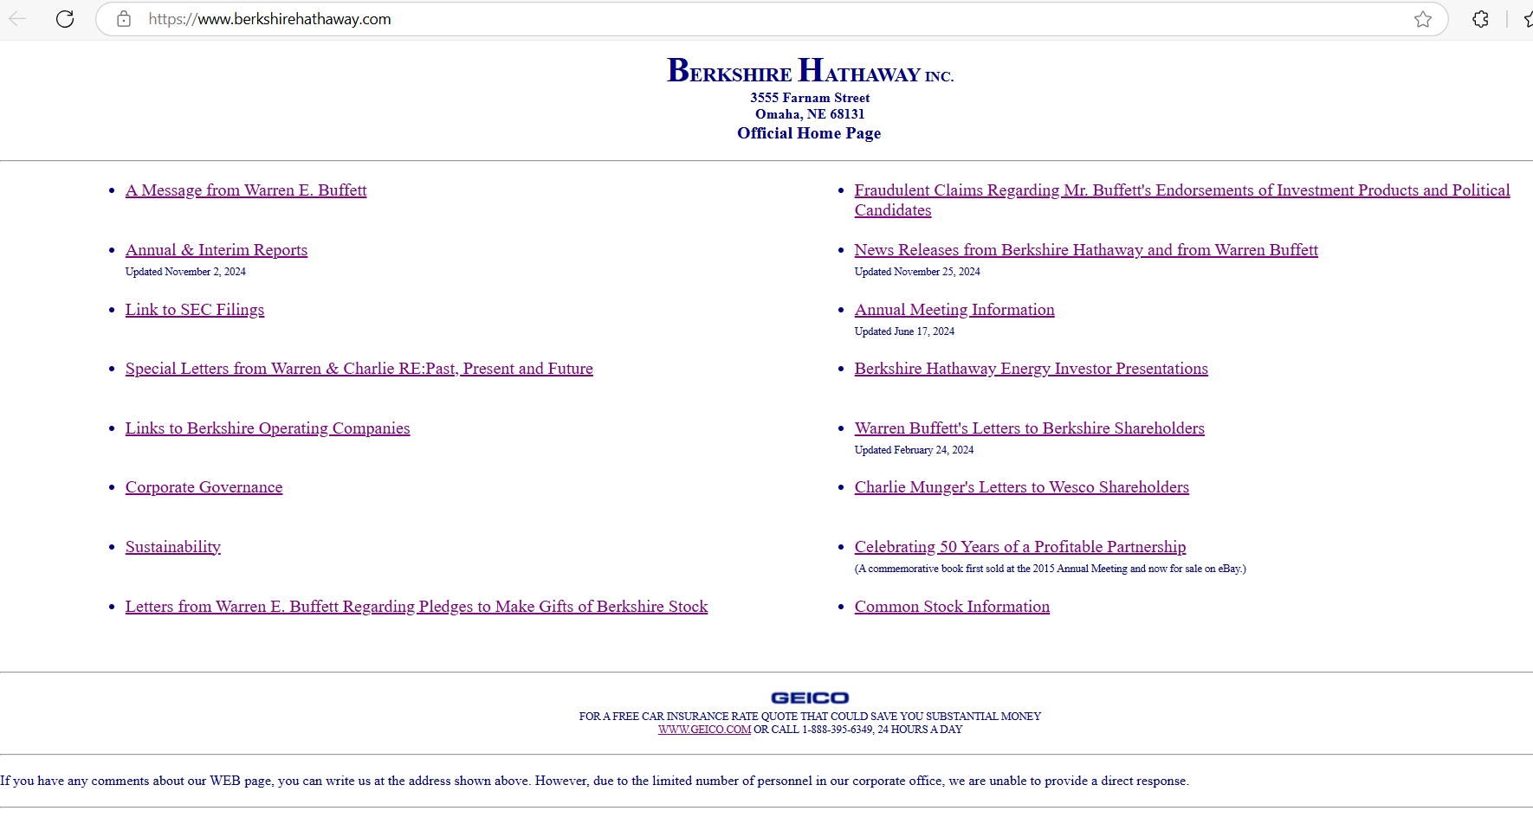

The monotonous typography and primitive design can be off-putting. It is also hard to understand what kind of service the company provides.

2)

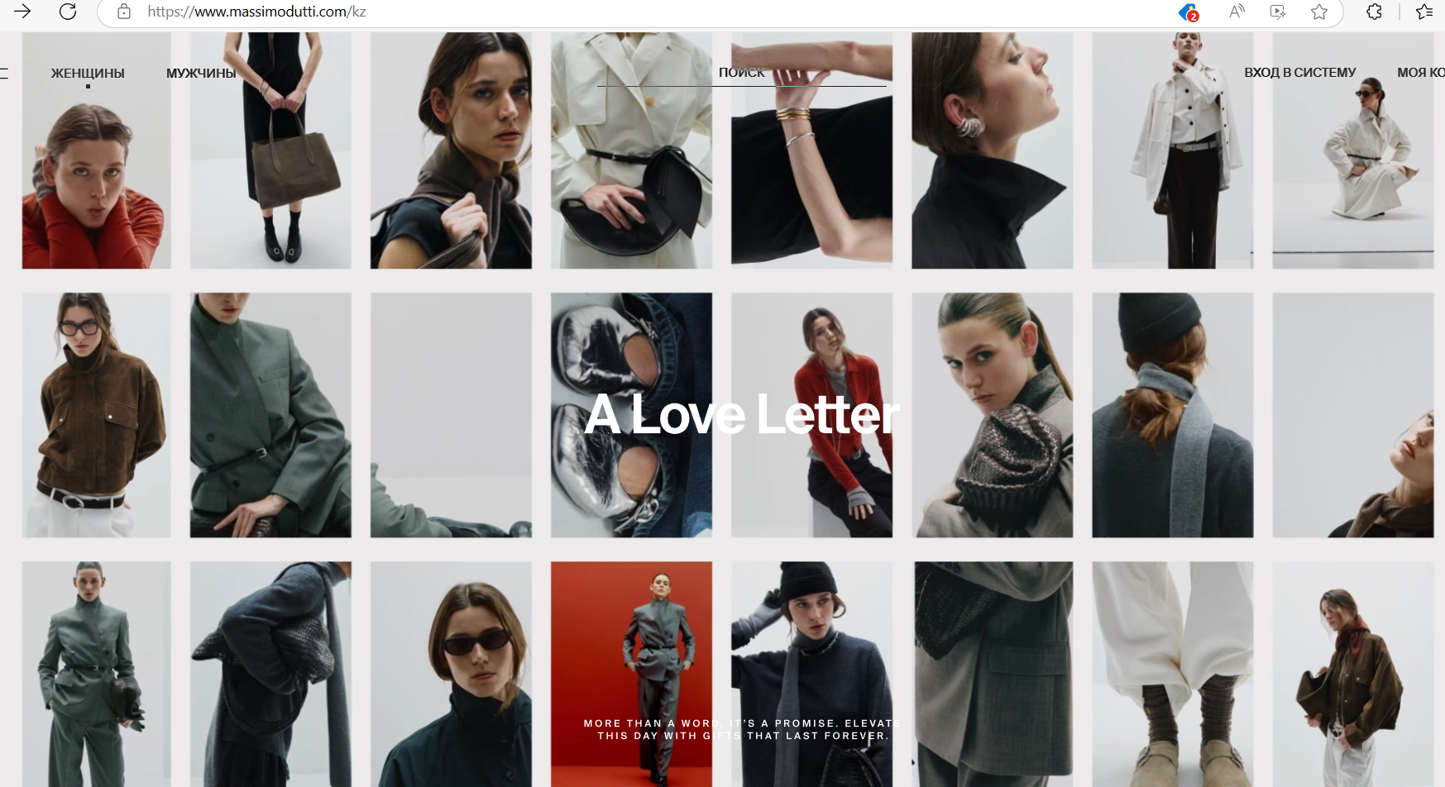

Massimo Dutti’s website. It’s really hard to notice the elements of the navbar

3)

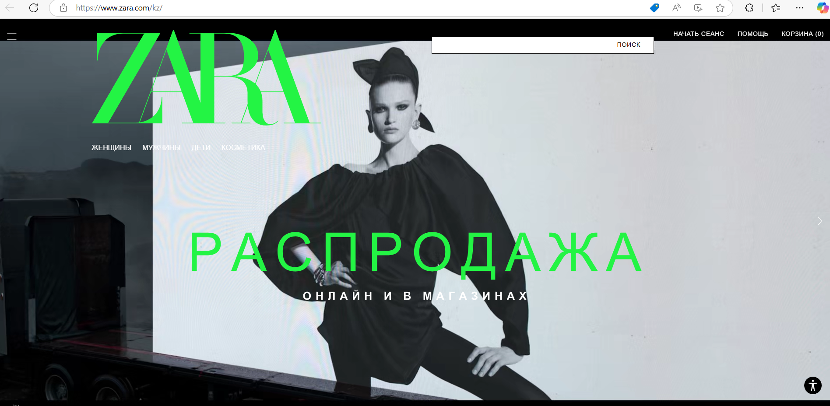

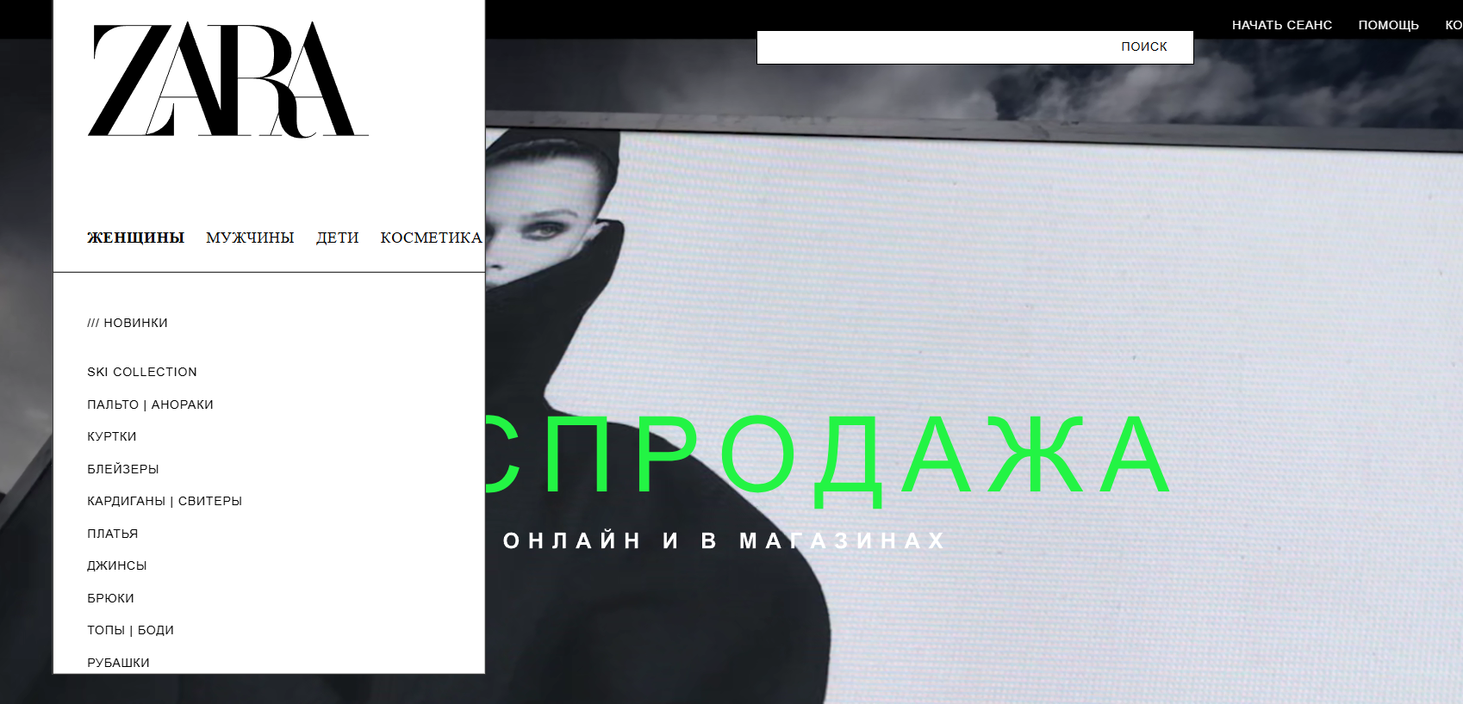

It’s hard to navigate because of the hamburger button

4)

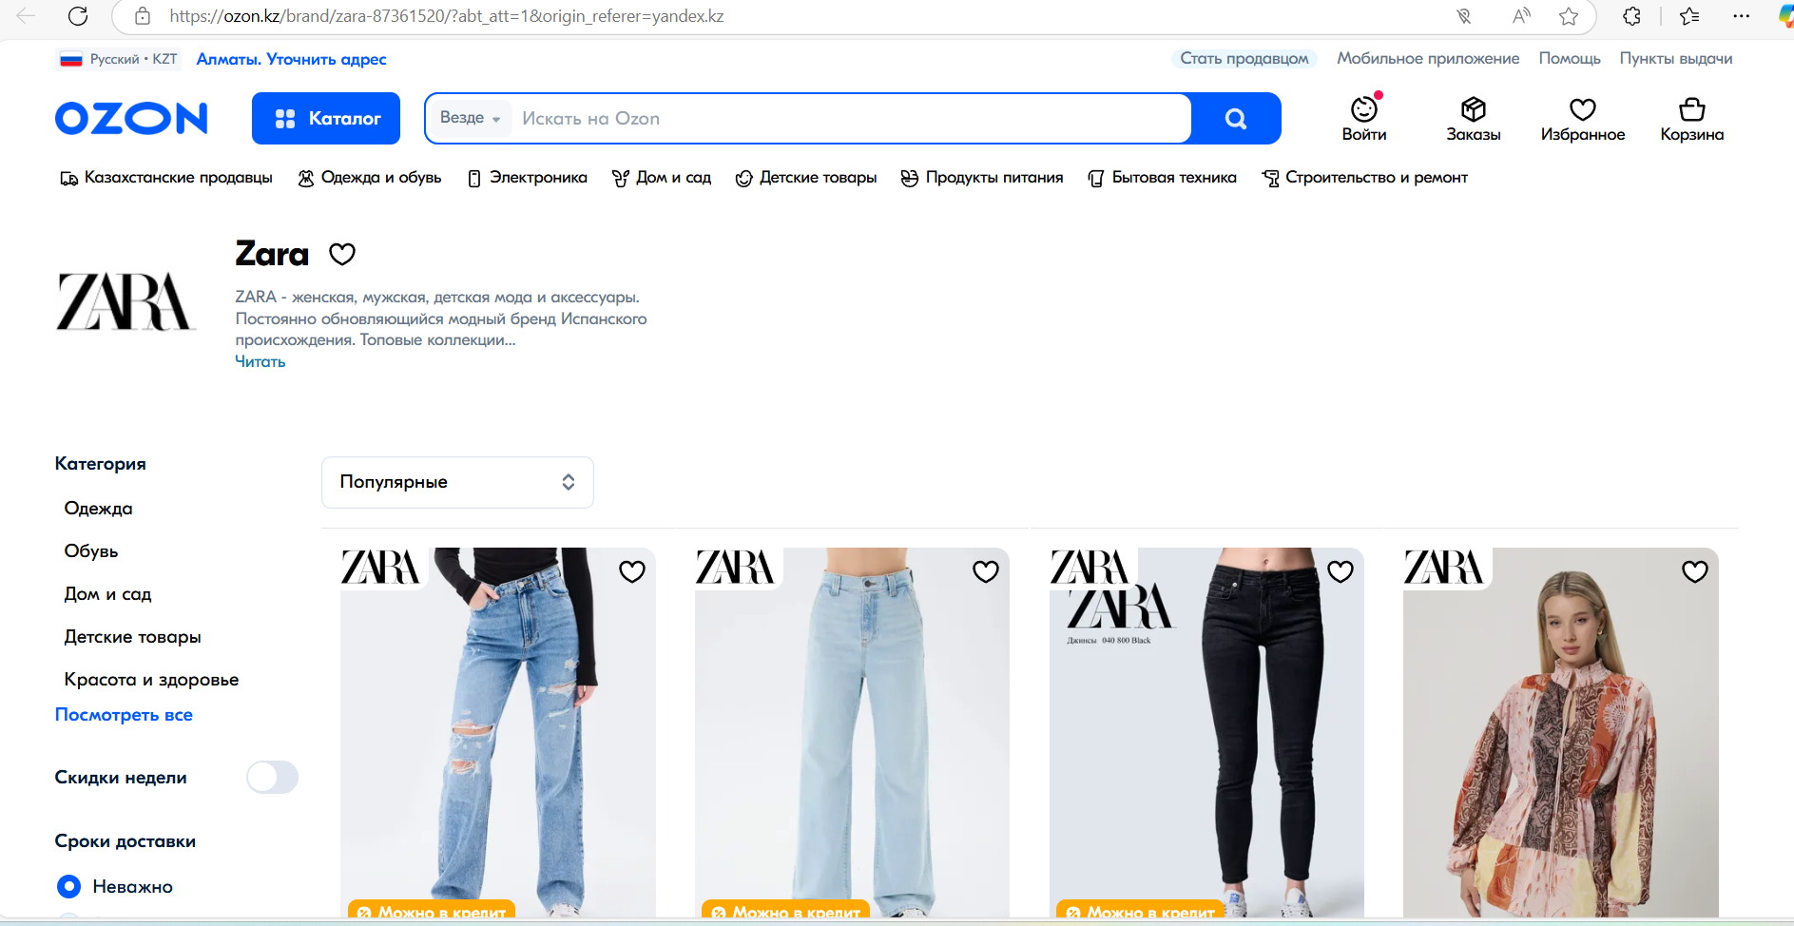

The website is overwhelmed with options. Especially the category fiels, what is the point to put the same information to navbar and sidebars

5)

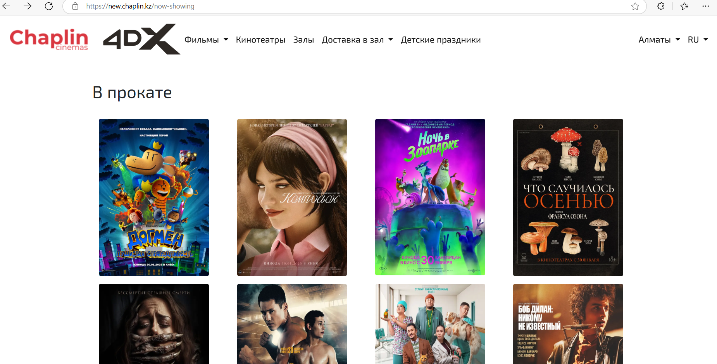

The link brings me to the page, only some gallery of films. There is no clear path for customer to checkout. And there is no search bar, where I can find the film I am interested in

6)

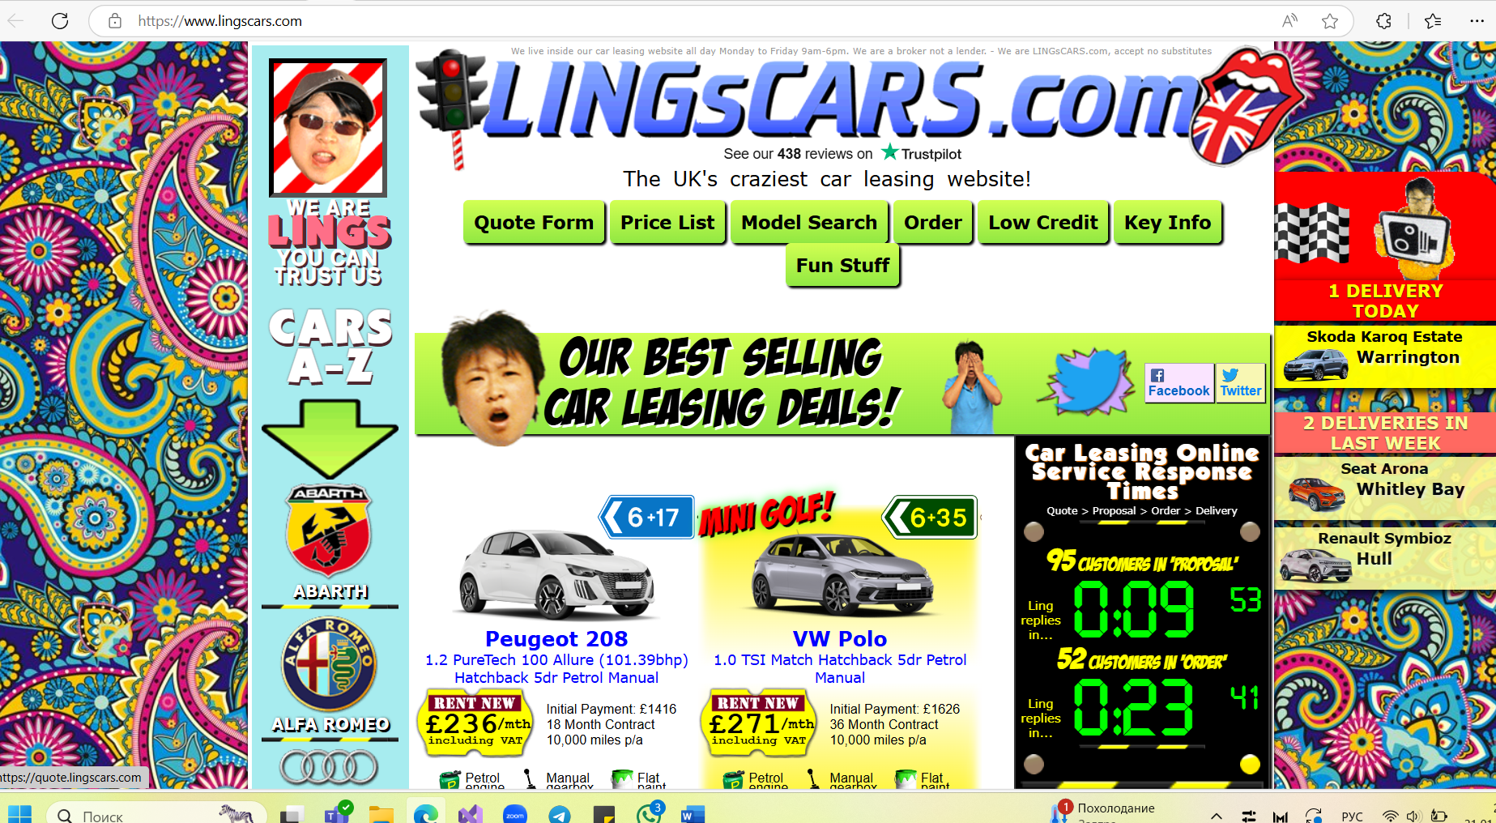

Too many colourful elements that can distrect the user. Also the design can make people think that this is a skam

7)

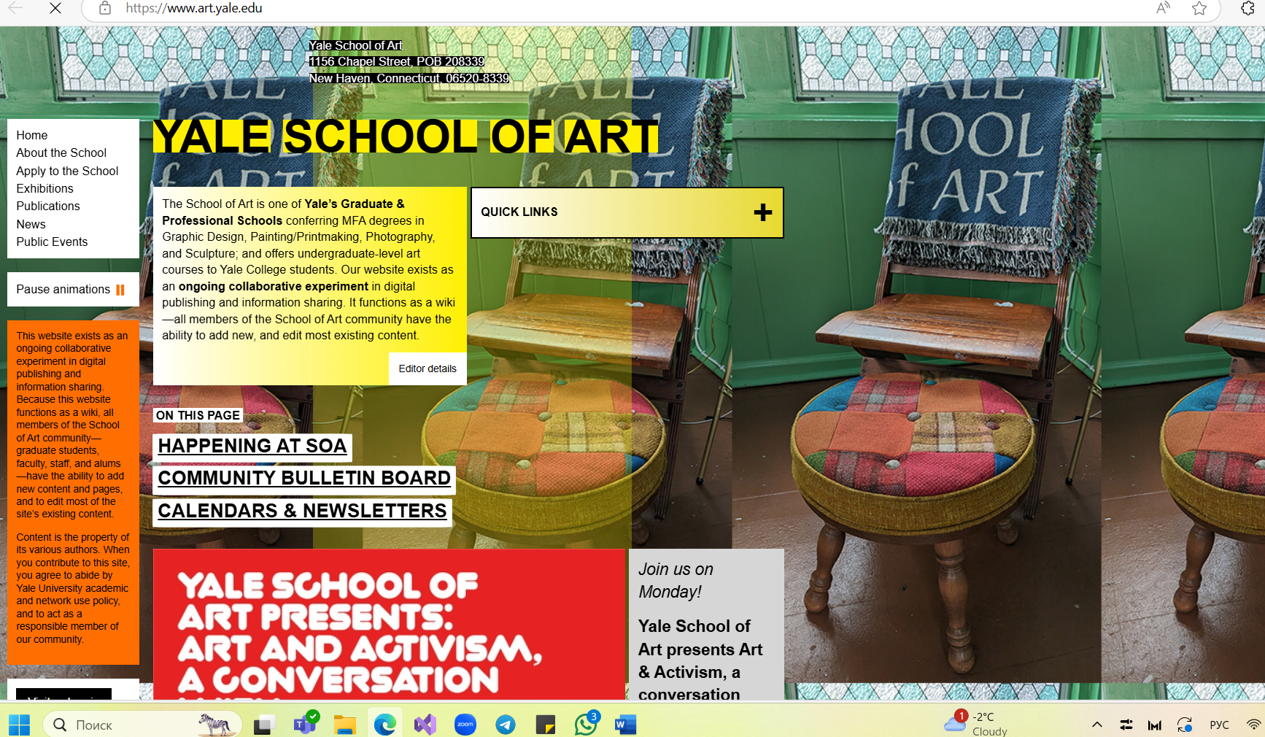

The navbar is not on the top how users are used to. The right side of website is tto empty, so it makes think that website did not loaded correctly

8)

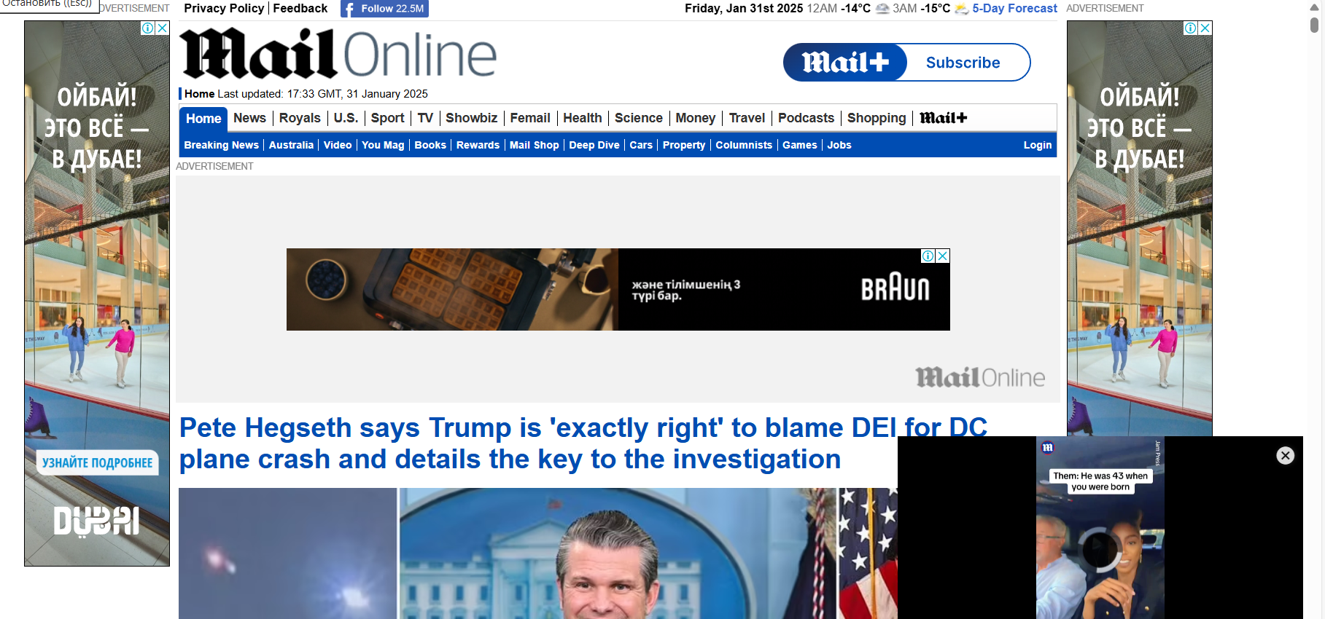

Too many advetisements, that can be mistaken as website’s information, its also brings some discomfort in using this page

9)

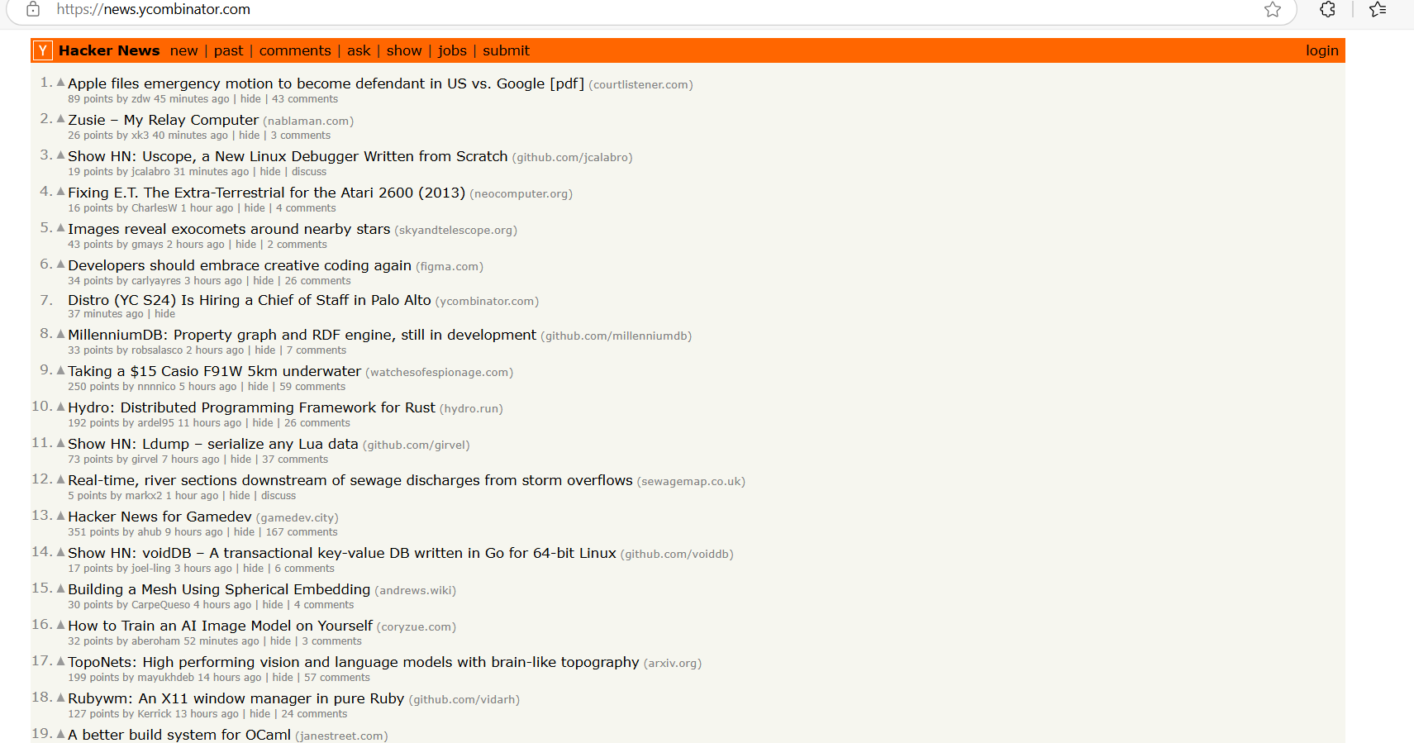

The information is pretty useful, but the design of elements are a little small and the text merges into one whole

10)

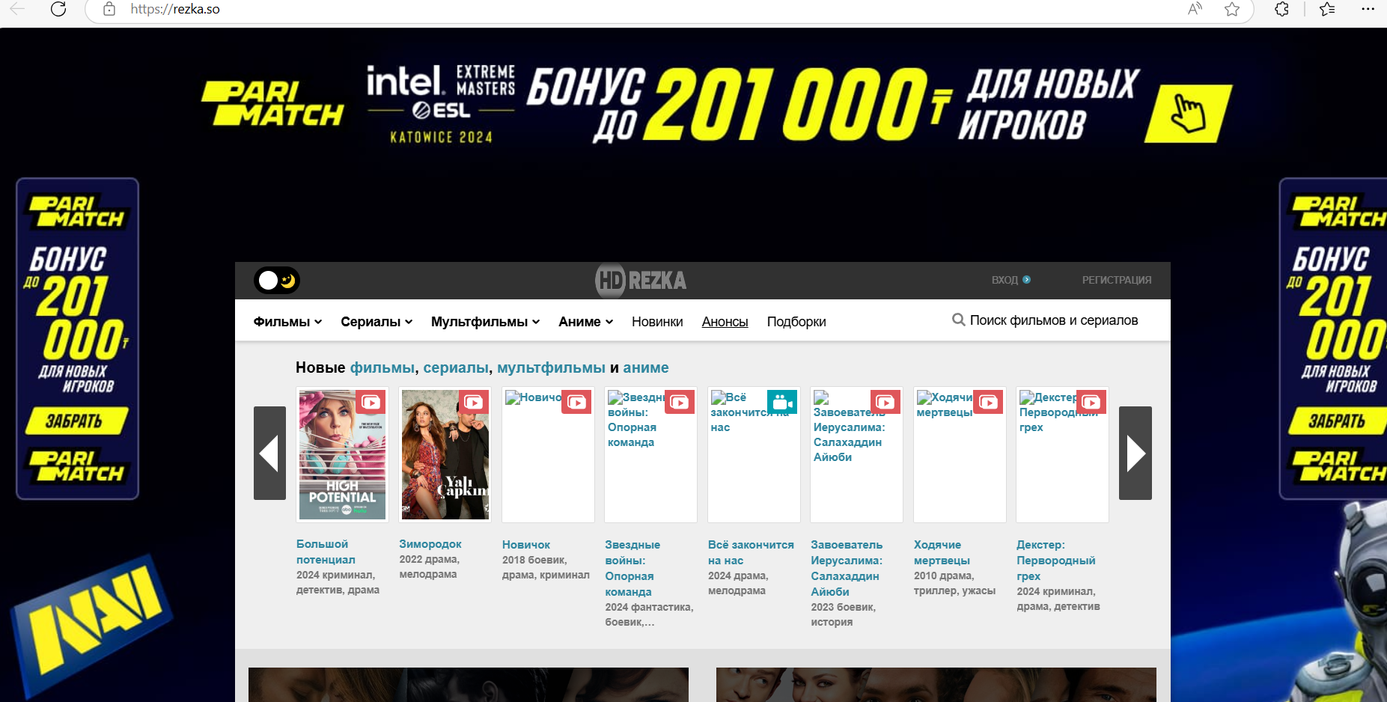

Long amount of time required to load this page, the search bar is on the left so user can not notice it immideatly and a lot of advetisement

* 1. What are your suggestions to not make the user have to think for those features? (give 10 examples of how to solve poor usability problems)

1) Give the desctiption of the website and make the categories to put to the navbar

2) Make the navbar more noticable and reduce the amount of moving elements

3) The hamburger navbar. It makes users to do the extra step to get what they want. So on the main page it is better to show the main parts of catalogue

4) Ozon should decide where they want to see the navbar on the side or in the top. Duplicating the information is not a great idea

5) Chaplin shouls show user the scenario of use, so should add the page where you can immideatly start buying the ticket

6) Use more calm colours and get rid of the head

7) Put the navbar to the top and distribute information evenly across the page

8) Implement a few add windows that do not overlap or merge with the content on the page

9) Make the containers for each news with heading and description underneath and proper header which can be easily noticed

10) Put the search bar to the center and make the page to load faster

* 1. What makes a website or application usable, user-friendly, an effective user experience?
     + 1. When it shows the scenarios how to use it
       2. Minimal distraction and intuitive navigation
       3. Fast load time
       4. Feedback, so user can see that he interact with website
       5. Clear call to action
       6. Design which resonates with the grouo of users who uses the website
       7. Secure login, data encryption, and privacy policies to build user trust.
  2. What is the first law of usability? What does it mean?

The first low of usability is ‘Don’t make me think’

It means that a website or application should be intuitive and self-explanatory, requiring minimal effort from users to understand and navigate. If users have to stop and figure out how something works, the design is not truly usable.

1. Save your finished document and upload it to the LMS. Make sure you have:
   1. Added your name to the space provided at the top of this document
   2. Renamed the document to include your Student ID.